Template for Evidence(s)
UI GreenMetric Questionnaire

University : ...
Country : ...
Web Address : …

[5] Transportation (TR)
SAMPLE
[5.9] Zero Emission Vehicles (ZEV) availability on campus (TR.3)

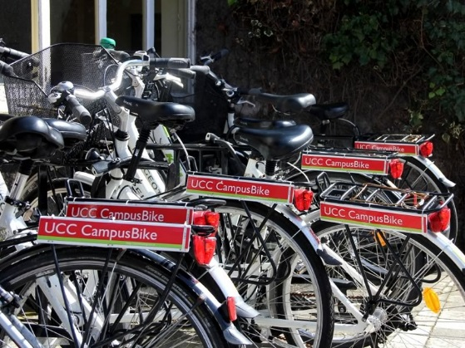 | 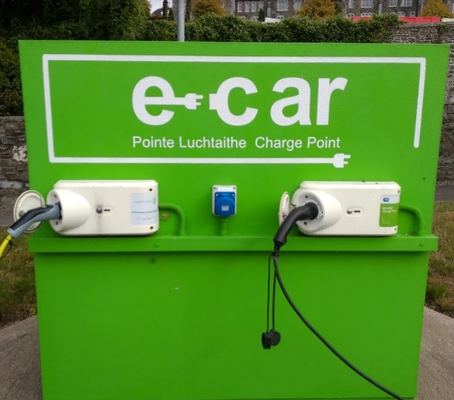
Example of Campus Bikes (University College Cork, Ireland) | Example of Charging points for EV (University College Cork, Ireland)
 | 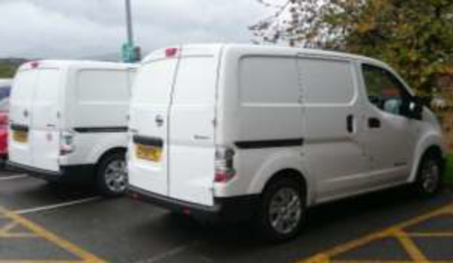
Example of Free Electric Vehicle Charging at The Ffriddoedd Carpark (Bangor University, UK) | Example of Zero Emission Vans (Bangor University, UK)

Description:
(Please describe the Zero Emission Vehicles (ZEV) policy on your campus. The following is an example of the description. You can describe more related items if needed.)

All Bangor University sites are cyclist and pedestrian friendly. Many have vehicle-free paths for these users. There is a 5 mph speed limit on all internal roads, and cycle paths on the public roads. All sites have cycle racks in a variety of designs. The University offers free showers to cyclists, runs a “Cycle to Work” scheme for staff as well as encouraging cycling through a number of services, events and groups, and providing free bikes to students.

No | Zero Emission Vehicle Type | Total
1 | Bicycle | 200
2 | etc | ...

Additional evidence link (i.e., for videos, more images, or other files that are not included in this file):

